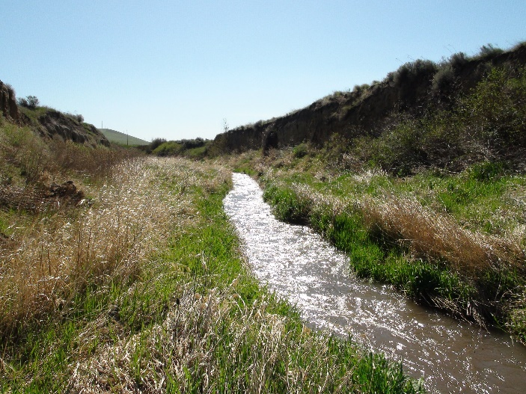
FY2015 Annual Work Plan

Pomeroy Conservation District
For More Information Contact: Duane Bartels, (509) 843 5008
pcdistrict@qwestoffice.net web page http://www.pomeroycd.com

Mission of the Pomeroy Conservation District
- To assist the farmers and ranchers of Garfield County with service, expertise, and funding to manage for the conservation , preservation and enhancement of the natural resources within the Pomeroy Conservation District. .

Natural Resource Priorities:
- Soil Health (nutrient management, erosion, etc).
- Weed Management (noxious and invasive weeds)
- Water Quality (nutrients, temperature, other)
- Range Management (native vegetation, water availability)
- Riparian Health (stream bank conditions, vegetation, etc.)
- Air Quality (field burning, prescribed burning, other)
- Wildlife
- Farmer Preservation (lens to look through at all above)
Program Area:
Information – Education
Goal(s):
- Provide a quarterly newsletter to inform producers of district activities and programs
- e-mail to all those with e-mail address
- use web site to provide district programs, local weather, news, newsletter, and etc.
- mail newsletter to those without e-mail and those that prefer hardcopies
- Newspaper articles when needed for better distribution of information
- Provide county rainfall information to local paper and web page on a monthly basis from participating rainfall stations located in county
- Conduct producer tours when projects of interest are completed and available
- Conduct spring and fall tours when needed.
- Conduct tour of CREP and other Riparian project sites when needed, invite legislators
Funding Source(s): Conservation Implementation Grant, CREP TA, Lead Entity, Basic Funding

Activities for FY2015 | Target Dates | Person  Responsible | Time (Days) Required | Estimated Funding | Notes
Newsletters, web page | July 14 thru June 15 | Duane Bartels & Pam Kimble |  | $1,000
Tours | July 14 thru June 15 | Pam Kimble |  | $500 | Schedule, setup, invites

Program Area: District Operations
Goal(s): By June 30, 2015, complete effective and efficient operations including accounting, grant vouchering, personnel management, Supervisor elections & appointments, training & development, annual planning and reporting
Funding Source(s): CREP,Commission, DOE, County Burn Program, IAC, District Grader
Activities for FY2015 | Target Dates | Person  Responsible | Time (Days) Required | Estimated Funding | Notes
Apply for funding from Commission, CREP, DOE, and SRFB to implement planned practices over this fiscal year. | July 14 thru June 15 | Duane Bartels |  | $3,000
Oversee and administer district programs and activities in an effective and efficient manner. | July 14 thru June 15 | Duane Bartels & Pam Kimble |  | $8,000
Operate Soil and water testing lab | Sep14 thru Apr 15 | Pam Kimble |  | $2,000
Operate district road grader | July 14-June 15 | Duane Bartels |  | $3,000. | During construction season
Cluster Engineer Program | July 1 thru June 30 | Gary Ausman |  | $80,000
Administer Engineer Program | July 1 thru June 30 | Duane Bartels |  | $8,750
Administer and assist CREP Coordinator and program in  Garfield and Whitman Counties | July 1 thru June 30 | Duane Bartels, Mike Denny |  | $130,000
Administer and conduct Burn Program in Garfield County | July 14-June 15 | Duane Bartels &Pam Kimble |  | $17,000 | Spring and Fall burn program
Administer DOE program | July 1 thru June 30 | Duane Bartels & Pam Kimble |  | $6,500
Administer Lead Entity program | July 1 thru June 30 | Duane Bartels |  | $2,500
Administer Weed Seeker Sprayer education and demonstration program with Pomeroy Grain Growers | July 1 thru June 30 | Duane Bartels |  | $750 | Year-round education and demonstrations
Goods and Services for all administration | July 1 thru June 30 |  |  | $20,000 | Copier, phone,web, office supplies, rent

Program Area: Upland Conservation, Soil Health, Range Management, Weed Management
Goal(s): Increase number of acres using no-till/direct seed in county by 10% by Nov. 2015 Implement other necessary conservation practices that will aid in the reduction of sediment delivery to our streams such as the use of the weed-seeker to reduce the cost of using chemical fallow.
Funding Source(s): Conservation Commission, Implementation Grant, DOE, CREP

Activities for FY2015 | Target Dates | Person  Responsible | Time (Days) Required | Estimated Funding | Notes
Introduction of programs to producers via newsletter and newspaper article | July 1 thru June 30 | Duane Bartels & Pam Kimble |  | $1,500
Take applications, process and administer funds for projects throughout the fiscal year until funding has expired | July 1 thru June 30 | Duane Bartels & Pam Kimble |  | $2,500
Implement upland conservation practices through BPA and Conservation Commission Grants | July 1 thru June 30 | Duane Bartels & Pam Kimble |  | $6,000
Cost Share Practices | July 1 thru June 30 | Duane Bartels & Pam Kimble |  | $30,000
PIP loan proceeds | July 1 thru June 30 | Duane Bartels &  Pam Kimble |  | $8,000

Program Area: Riparian Health, Restoration and Enhancement, Water Quality
Goal(s): Implement 10 more projects to improve the management of livestock in the riparian areas
along the streams in Garfield County. Assist federal programs (CREP,CCRP, and EQIP) with funding
to further implement those type programs when needed
Funding Source(s): Conservation Commission, DOE, EQIP, RCO

Activities for FY2015 | Target Dates | Person  Responsible | Time  (Days) Required | Estimated Funding | Notes
Take applications, process and administer funds for projects throughout fiscal year until funding has expired | July 1 thru June 30 | Duane Bartels, Pam Kimble |  | $2,000
Implement riparian restoration and enhancement practices thru RCO, DOE, CREP, and other cost share programs | July 1 thru June 30 | Duane Bartels |  | $2,000
Cost share funds available | July 1 thru June 30 |  |  | $25,000

FY2015

Annual Budget

Pomeroy Conservation District

 | Income
DOE CS | $10,000
CREP CS/Maint. | $15,000
CREP TA | $100,000
CREP TA other districts | $18,000
CREP TA admin | $12,000
Cluster Engineer grant | $75,000
Cluster Engineer additional income | $15,000
Implementation CS | $30,000
Implementation Admin/ G&S | $35,000
Miscellaneous Income | $1,000
DOE Admin | $6,500
Basic Funding | $12,500
Lead Entity | $2,000
Burn Permits | $13,000
Tree Sales | $400
Maps, Raingauges, etc. | $150
Soil testing | $1,000
Finance Chg. Collected
Grader Rental Income | $5,000
Sales tax collected | $450
PIP loans | $8,000
Total Income | $360,000

 | Expenses
Cost Share | $55,000
Dist. Mgr. salary & benefits | $69,000
Dist. Tech. wages & benefits | $26,000
Cluster Engineer salary & benefits, G&S | $87,500
CREP Status Reviewer | $2,500
CREP TA &G&S | $70,500
CREP TA from other districts | $10,000
Building rent and electricity | $8,400
Lab supplies | $500
Copier Expenses | $2,400
Grader Fuel, Maint. Repair | $2,000
Web Site Service | $500
Internet & phone Service | $1,500
Travel Per Diem | $2,000
Election Expenses | $100
Office supplies | $522
Miscell. Dues, etc | $4,500
Cellphone | $368
Computer Expense | $500
Information Edu. Materials | $500
Postage | $200
Insurance and bonds | $3,500
Storage at Port | $660
Vehicle license, fuel, maint. | $2,500
Misc. expenses
Trees and shrubs | $400
Sales tax, B&O | $450
PIP Loan Payments | $8,000
Total Expenses | $360,000

