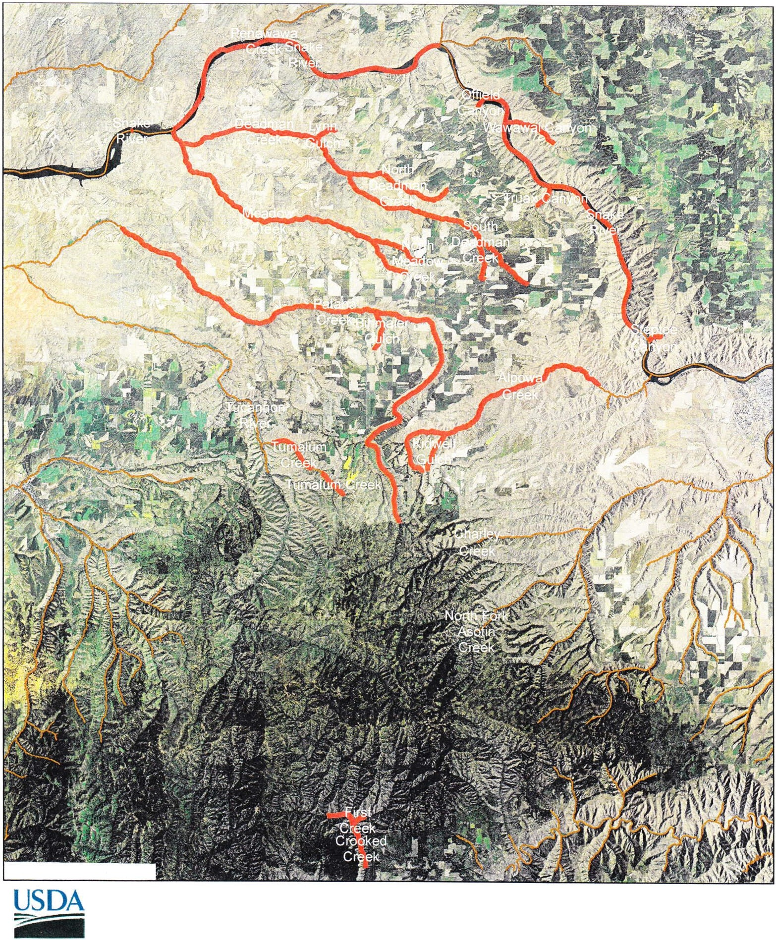United States Department of Agriculture
Farm Service Agency Garfield County
- - +

Pomeroy CD CREP Streams

0 10,5001,000 42 ,000 63,000 84,000

Feet

Disclaimer: Wetland identifiers do not represent the size, shape or specific determination of the area.
Refer to your original determination (CPA-026 and attached maps) for exact wetland boundaries and determinations,or contact NRCS.

-<all other values>
DIST_NM

