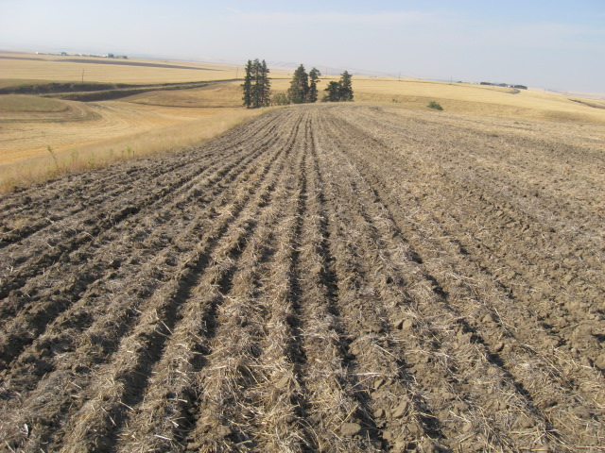

Habitat for Fall Chinook and Steelhead

January 2013 – December 2013 Habitat Conservation Projects

Cooperators:
Bonneville Power Administration
Washington State Conservation Commission
Washington State Department of Fish and Wildlife
Natural Resources Conservation Service
Umatilla National Forest, Pomeroy Ranger District
Farmers and Ranchers of Garfield County

Annual Report for Parent Project 1994-018-07

Contract #53339 & #57424

May 2014

January 2013 thru December 2013

Habitat Projects Completed

Prepared for:

U.S. Department of Energy
Bonneville Power Administration
Environment, Fish and Wildlife Division

Washington State Conservation Commission

Washington Department of Fish and Wildlife

Umatilla National Forest, Pomeroy Ranger District

Natural Resources Conservation Service

By:

Duane G. Bartels
District Manager
Pomeroy Conservation District
804 Main P.O. Box 468
Pomeroy, WA 99347
E-mail- pcdistrict@qwestoffice.net
Web site www.pomeroycd.com

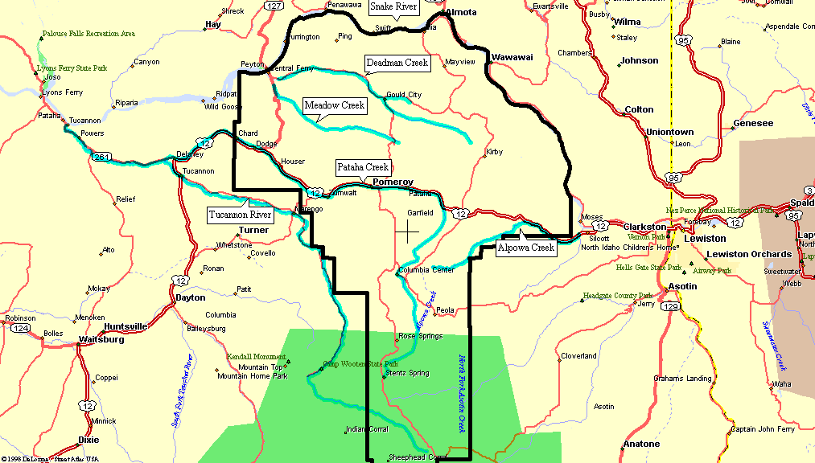
Garfield County in SE Washington

Table of Contents

Map of County 2
Abstract 3
Introduction 4
BPA Budget Summary 5
Project Summaries 6
Soil Erosion Documentation 6
Pomeroy CD Ongoing Efforts 7
2011 CS Projects: Contract #48075 & 53339 7-8
No-till drill 8
Weed seeker 9
Other CS practices applied 10
Map of practices applied 11
Water Quality 11-12
Report Conclusion 12
References 13

Abstract
The objectives and tasks outlined in detail in this project report were implemented during calendar year 2013 in all the watersheds of Garfield County. The Pataha Creek Watershed was selected in 1993, along with the Tucannon and Asotin Creeks, as model watersheds by the Northwest Power and Conservation Council (NPCC). In the years since 1993, other watersheds in Garfield County have been designated as salmon bearing streams and have used numerous practices formerly initiated in the Pataha Creek Watershed. The following sections show the individual practices, quantity of practices implemented, total costs, BPA costs for all the BPA funds used to protect and enhance the natural resources in the Pataha Watershed..
Of the entire cost share received in the county, 0% came from BPA. The funding was used for administration costs and goods and services. This is largely due to other funding programs becoming available to address livestock influenced water quality problems and riparian health improvement.
In 1993, over 95% of the sediment entering the stream can be tied directly to the upland and riparian areas of the watershed according to studies conducted by WSU and Oregon State University. At the present time, it is estimated that less than 50% comes from the uplands that includes cropland and rangeland. The remaining sediment is coming from vertical streambanks and unprotected riparian areas.
The Pataha Creek, Deadman Creek, and Alpowa Creek have had steelhead runs in the past. The Pataha Creek have native and planted rainbow trout in the mid to upper portion. The lower portion of Pataha Creek’s habitat has improved over the years to where it was designated in 2012 as a MSA (major spawning area) from a mSA (minor spawning area). The improvement of riparian habitat through the CREP, CCRP, and DOE grants has improved habitat for all the fish species and led to this new designation. The Washington State Fish and Wildlife set up a fish trap in the lower portion of the Pataha Creek and trapped 40 Steelhead above the Delaney culvert in 2011 (see picture on lead page). However, barriers at Delaney and Dodge Junction inhibit migration during normal to low flows so funding from the Salmon Recovery Funding Board was received by the Umatilla Tribe to remove these barriers. That project was completed during the summer and fall of 2011. With the removal of these migration barriers on the lower portion of the Pataha, more stream miles will become useful spawning and rearing habitat.
The upland projects completed during 2012 were practices that significantly reduce the erosion and resulting sedimentation from these croplands. Runoff studies conducted by WSU in the past have shown a direct impact on reducing soil erosion by the implementation of these practices.
The tree planting projects conducted under the CREP (Conservation Reserve Enhancement Program) and CRP (Continuous Conservation Reserve Program) programs have helped reduce sedimentation and have also improved the riparian zone in desired locations inside the Pataha, Deadman, and Alpowa Creek Watersheds. The CREP and the CCRP programs have slowed but we continue with enrollment in the watersheds and are protecting the riparian areas along these three streams at an increasing level every year. Currently, over 1,200 acres of riparian habitat have been enrolled in the CREP program within these three watersheds.

Introduction
Due to the high value of the fish resource in the Tucannon River, there have been many studies and planning efforts directed at restoring resource conditions in this watershed. Pataha Creek, as the largest sub-watershed in the Tucannon watershed was identified as one of the primary contributors of sediment to the Tucannon River. Continued upland and riparian restoration efforts since 1993 has greatly reduced the Pataha’s impact on the Tucannon. The Alpowa Creek has a good run of Steelhead but has also suffered from riparian degradation and embeddedness. Deadman Creek has Steelhead but lack of riparian vegetation and embeddedness from sedimentation which has reduced its production capability.
- This sediment reduction project was proposed to the Northwest Power and Conservation Council in 1993 to help address some of these problems through the model watershed process.

BPA Budget Summary
- BPA funding under contract #57424 and #61567 was used for salaries and benefits for the coordinator and administrative assistant, travel expenses, and goods and services needed for the administration of the cost-sharing program for the calendar year 2013.
The following summary reflects this calendar year of expenses:

Table 1: Budget Summary
Salaries & Benefits:
Coordinator $ 32,415
Clerical $ 12,077
Total $44,492

Goods and Services:

Total $ 4,789

Total cost of CS program to BPA $49,281

Project Summaries

Watershed Project Coordination and Administration for 2013; Contract #57424&61567
The Pomeroy Conservation District was provided funding from the BPA to continue the administration and implementation of approved conservation practices in Garfield County. It follows the intent of the Pataha Creek Model Watershed plan developed in 1993. This plan was a pilot effort to encourage private landowners to join government agencies in finding solutions to loss of salmon habitat and critical riparian areas. The goal of the plan is to set into motion efforts to return the upper Pataha Creek Watershed and lower Tucannon River to productive capacity for salmon spawning and rearing.
The Pataha Creek’s past high delivery of sediment and high water temperatures into the spawning and rearing area of the lower Tucannon River was determined to be the main problem in the Pataha Creek Watershed.
Since 1993, the watershed coordinator has worked to bring together the technical experts of state and federal agencies with private landowners to jointly find solutions to habitat problems within the watershed and now within some other salmon bearing streams in Garfield County. The technical representatives provide the scientific background and information on critical needs of the fish while the landowners provide the common sense backstop to ensure that the action items suggested by the agencies are attainable, physically and financially within the watershed.

Soil Erosion Documentation

The following research has been used as a guide in the district effort to use cost share of no-till seeding as a basis of improving the water quality of all the streams in the Pomeroy Conservation District.

Submitted to: ASAE Annual International Meeting
Publication Type: Proceedings/Symposium
Publication Acceptance Date: January 16, 2003
Publication Date: July 27, 2003
Citation: FU, G., CHEN, S., MCCOOL, D.K. SOIL EROSION AND ITS RESPONSE TO NO-TILL PRACTICE ESTIMATED WITH ARCVIEW GIS. ASAE ANNUAL INTERNATIONAL MEETING. 2003.
Interpretive Summary: Reliable estimates of the effect on soil erosion and downstream sediment yield of crop management and land use changes are important in determining if these changes will result in the benefits expected. Changes in crop management practices may show reduced erosion on small plots, but the effect on sediment yield and fish habitat in downstream channels will be influenced by many factors in addition to those that cause small-plot erosion reduction. Applying the RUSLE and Arcview GIS to the Pataha Watershed in southeastern Washington resulted in soil loss estimates on individual 10mx10m grid cells that showed average soil loss reduction from 11.1 to 3.1 t/ha.yr by converting from current to no-till practices on cropland. Using the Sediment Delivery Distributed (SEDD) model with the ArcView GIS indicated a sediment delivery from the watershed of 4.7 t/ha.yr under current management practices, and 1.5 t/ha.yr if all cropland were converted to no-till practices. This research is an important step in establishing procedures to determine the off-site benefits of using management practices such as no-till seeding or permanent contour grass strips. A procedure for determining off-site benefits of specific crop management practices is important because additional costs of applying these practices could be covered by external funds as part of fish habitat and species recovery efforts.
Technical Abstract: ArcView GIS and the Revised Universal Soil Loss Equation (RUSLE) were used to estimate soil erosion and its response to no-till practice in Pataha Creek Watershed, a typical dryland agricultural watershed in southeastern Washington. With the aid of GIS and appropriate formulas specific to Pacific Northwest region, L and S factors were calculated from DEM, and Req factors from precipitation map. K factors were obtained from SSURGO database, and C factors were calculated from RUSLE 105 using crop rotation and land use maps. ArcView GI was used to obtain soil erosion from each 10mX10m cell. The results show average cell soil loss of about 11.09 t/ha·yr under current land use. The Sediment Delivery Distributed (SEDD) Model integrated with GIS was employed to estimate the transport of eroded soil past the gaging station. The result showed that the average cell sediment yield from the 327 sq km area above the gaging station is 4.71 t/ha·yr, about 42.4% of the total soil loss. Channel erosion was not included in this study. The impacts of adopting no-till practices were then calculated by running RUSLE under the scenario of all the agricultural land under no-till practices. The average cell soil loss decreased from 11.09 to 3.10 t/ha·yr for the whole watershed and from 17.67 to 3.89 t/ha·yr for cropland under no-till. The average cell sediment yield to river channel decreased from 4.71 to 1.49 t/ha·yr for the entire watershed and from 7.11 to 1.55 t/ha·yr for cropland under no-till scenario. The contribution of cropland decreased from 92.4% to 72.8% for soil loss and from 87.4% to 60.1% for sediment yield if all the cropland in the Pataha Creek Watershed were under no-till practice. These modeled results are consistent with other studies either in this region or other regions.
Pomeroy CD Ongoing Efforts

The Pomeroy Conservation District has worked with the Washington State Conservation Commission, Bonneville Power Administration, Washington State Department of Ecology, and the Natural Resources Conservation Service since the beginning of this pilot program. We have jointly implemented conservation practices to help reduce the erosion and resulting sedimentation moving from our uplands into all the streams of Garfield County. We have also installed practices within the riparian area to improve bank stability, riparian vegetation, and in-stream fish habitat.
The Pomeroy Conservation District was involved in the sub basin planning process for the Tucannon Sub basin and was the lead for the Lower Snake Sub basin. This process took over a year with funding provided by the NPCC. These two plans were delivered to the NPCC on May 28, 2004.
The following sections illustrate the projects implemented under the Washington State Conservation Commission Implementation and Department of Ecology grant in 2013.

Farmers who elected no-till or direct seeding were eligible for cost-sharing at $20 per acre. Three years ago, the board of supervisors implemented a policy that if a producer receives 3 payments ($5,000 limit per payment), that they could no longer receive cost share for no-till. The board felt that the funding should be used to introduce the producers to the practice and that three years would be long enough for the producer to decide if he wanted to use the no-till practice in his farming operation. This policy spread the limited funding under this contract among more farmers and reduced the amount that one operator could continue to receive.
Figure 2 No-till drill
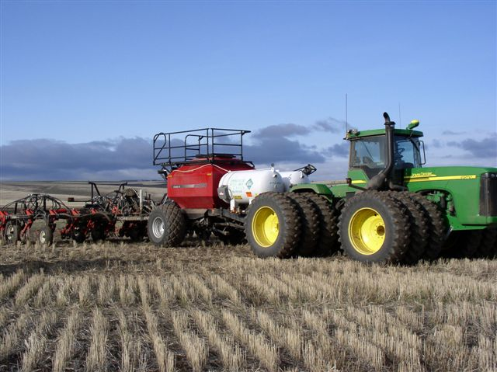

This drill (Figure 2) and others similar to this are used to no-till and direct seed grain crops into soil that has remained undisturbed since the last crop. The drills are capable of preparing a seed bed, placing fertilizer, and seeding in one operation. Direct seed uses a separate implement to place the fertilizer but with very little soil disturbance. The advantage of this seeding system is the overall reduction in soil erosion and the improvement of soil health. As the roots from past years’s crops decompose in the undisturbed soil, they release nutrients and organic matter and leave pockets of air for moisture to enter. When soil is not cultivated as it has been in the past, a much lower amount of carbon dioxide is released into the atmosphere. The soil is not left exposed to the elements and will not erode from the crop fields into nearby streams. No-till or direct seeding in conjunction with annual cropping and crop rotations is one of the very best ways to reduce upland erosion and the resulting sedimentation into our fish bearing streams.

This is the new weedseeker sprayer obtained by the district with funding provided by the Washington State Department of Ecology. The 60 ft. sprayer is equipped with weedseeker technology that sprayer only green growth. It is stated by the manufacturer that it will reduce herbicide use by up to 85%, especially on a chemical fallow operation during the 2nd and 3rd spraying operation. The sprayer will be available for the 2010 summer season. AgPro Inc. of Lewiston, Idaho built the sprayer with the sensors and spray nozzles being provided by AgTeq Inc. of The Dalles Oregon.

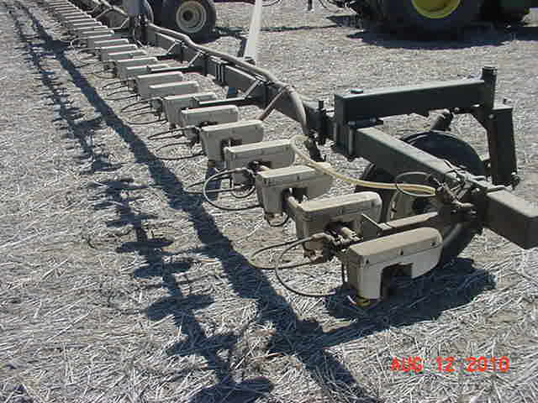

. Figure #2 Pomeroy CD new Weed seeker sprayer

The summer of 2013 was the 3rd year of operation. The Pomeroy CD signed an MOU with the Pomeroy Grain Growers to operate and maintain the sprayer. Due to the fact that the price of Glyphoste (Roundup) has dropped to half the price it was in 2010, the demand on reducing the amount of herbicide due to the price per gallon, has dropped significantly. The sprayer only covered about 900 acres during the summer. The late spring weather caused weed germination throughout the early summer and the benefits of the weed seeker could not be utilized. The reduction varied from 80% down to 40% . The reduction varied because in many cases, the recipe of herbicide was increased to increase the mortality of the weed kill and was difficult to calculate the actual savings compared to using the same recipe with a conventional weed sprayers. We have learned that other chemical dealers are thinking about obtaining the technology of the weed seeker and operating their own custom sprayer. That was the overall goal of the Pomeroy CD when they sought funding for the original weed seeker.

2013 Cost Share practices from other programs
*Implementation – Conservation Commission
*CREP – Conservation Commission
* DOE – Department of Ecology
*DNR – Department of Natural Resources
Table 4: Other conservation practices and water quality improvement practices
CS # | Operator | Practice | Funding Source | Cost Share | Match
 | Nikki and Cody Jones | Cultural Resources Slurvey | DOE | $1,275 | $425
8341 | Mike Hastings | No-till seeding | Commission | $4,800 | $4,800
8339 | Samee Ledgerwood | Sediment Basins | Commission | $1,600 | $1,600
8340 | Dick Ledgerwood and Son | Sediment Basins | Commission | $800 | $800
 | McGreevy Bros. | CREP Maintenance | Commission | $1,520 | 0
823 | Gary Slaybaugh | CREP Maintenance | Commission | $3,685 | 0
 | Dick Ledgerwood and Sons | Riparian Fencing | DOE | $3,750 | $1.250
 | 7JK Ranch | Livestock watering facility | DOE | $3,469 | $1,156
 | Roger Dumbeck | CREP CS | Commission | $130 | $1,170
 | Virginia Boyd | CREP Maintenance | Commission | $1,316 | 0
 | McGreevy Bros. | CREP Maintenance | Commission | $1,375 | 0
 |  | Total |  | $23,720 | $11,201

Water Quality Monitoring in Pataha Creek Watershed; Contract 17137 supporting a WDOE grant
At the present time, we are not operating on ISCO sampler in the county. The remodeling of the high school cut off the electrical service we used for the sampler. It was decided that a couple years should pass before monitoring is resumed in order to show a true trend in the improvement of the water quality. Budget reductions have delayed the re-start.
In the past, WSU has conducted the water quality-monitoring program in the Pataha Creek Watershed, Deadman Creek Watershed, and Alpowa Creek Watershed. They collected temperature (°C), sediment (Total Suspended Solids –TSS), fecal coliform (cfu/100mL), flow (cfs), ammonia (ppm), nitrate (ppm), total Kjeldahl nitrogen (TKN –ppm), and total phosphorus (ppm) data from five sites in the Pataha sub basin. A Watershed Scale Study on no-till farming systems for reducing sediment delivery conducted by WSU is also available at the district. These will be placed on the district web site when it goes on line in March 2008. A detailed explanation of monitoring protocols and methods was given in the April 2003 report covering all data collected, protocols, and procedures. The data shows that from 1998 thru 2007, a steady decline in all segments (Fecal coliform, sediments, etc.) has been shown.

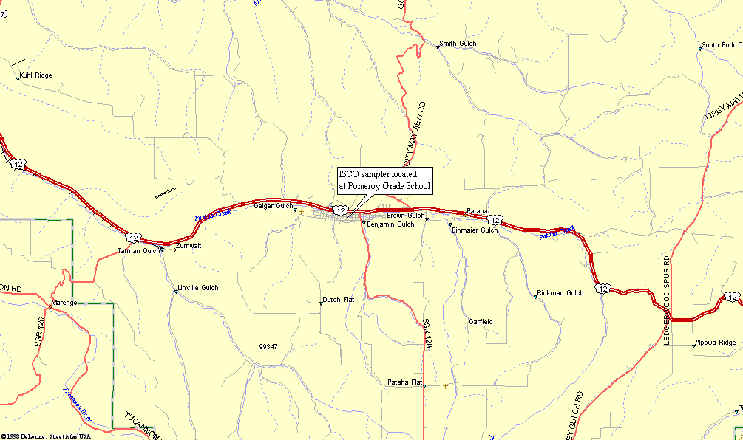

Report Conclusion
This report describes the activities and associated costs within the Pataha Creek Watershed from January 2013 through December of 2013.
$67,240 was allocated to the Pomeroy CD from BPA for 2013. Other funding was provided through the Department of Ecology, Department of Natural Resources, and the Washington State Conservation Commission to keep a voluntary program to implement BMP’s on the ground. With sub-basin planning completed for the Lower Snake and Tucannon sub-basins, new activities are bringing the program back to par and we are continuing with the implementation of habitat restoration and sediment reduction practices.
The Pomeroy Conservation District would like to thank the Bonneville Power Administration for the funding they provided. The habitat in Garfield County is being improved and the Pomeroy CD will continue its efforts to enhance and restore habitat for the fish and wildlife within the watershed's boundaries.

References
The following lists the publications are available for reference to the restoration and enhancement program currently underway in Garfield County.
Southeast Washington Cooperative River Basin Study (USDA 1984): The objective of this study was to provide a basin-wide evaluation of existing land management and stream habitat conditions related to erosion and sediment problems.
Pataha Creek Water Quality Report 1998-2001: The objective of this study is to evaluate the water quality in the Pataha Creek watershed in an effort to determine the effectiveness of agricultural conservation practices in southeast Washington’s Pomeroy Conservation district. Data presented were collected between March 1999 and July 2001, and then analyzed by Washington State University’s Department of Biological Systems and by the Center for Environmental Education.

Improving Erosion Prediction to Enhance Soil and Water Quality
- http://www.ars.usda.gov/research/publications/publications.htm?SEQ_NO_115=152852

Sustainable Farm Systems Improving the Quality of Life in the Pacific Northwest
http://www.directseed.org/sustainablefarming.html

