5-Year Plan (2014 to 2019)
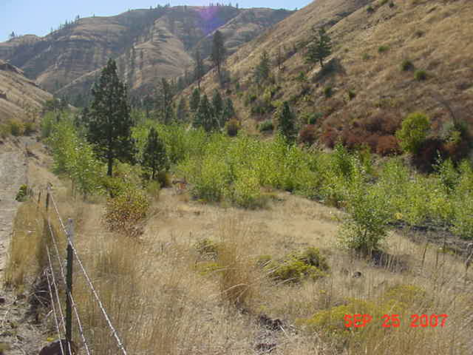

Pomeroy Conservation District
For More Information Contact: Duane Bartels 509 843 5008 pcdistrict@qwestoffice.net

Organization of the Pomeroy Conservation District
The Pomeroy Conservation District is a political subdivision of the State of Washington with authorities, powers and structure contained in Revised Code of Washington (RCW) 89.08.
- The Pomeroy Conservation District was formed under the RCW in 1950

Function of the Pomeroy Conservation District
The function of the Pomeroy Conservation District is to make available to the residents of Garfield County, the technical, financial and educational resources, whatever their source, and focus or coordinate them so that they meet the needs of the local land manager with conservation of soil, water and related natural resources.

We Serve & Why
- Citizens of Garfield County - to educate and help them to protect and enhance the counties natural resources.
- Future Generations - to preserve, protect, and enhance the natural resources of today so they will be available to our future generations.
- Neighboring Counties – to work with neighboring counties in a combined effort to protect and enhance the natural resources of our entire region.

Mission of the Pomeroy Conservation District
  - To assist the farmers and ranchers of Garfield County with service, expertise, and funding to manage for the conservation, preservation and enhancement of the natural resources within the Pomeroy Conservation District.

Vision of the Pomeroy Conservation District
- Sustainable agricultural base and retention of family farm living.

Values of the Pomeroy Conservation District
- Honesty and integrity
- Conservation of all natural resources
- Public awareness of our goals and objectives
- Economic Efficiency and Viability

Land Manager Needs:
  - Assistance…financial, technical, educational
  - Go between (intermediary) with agencies…regulatory and otherwise
  - Share all options for how to address conservation issues
  - Supervisors and staff awareness of producer issues
  - Receive input from operators, hash out solutions to issues

Natural Resource Data Review & Google Earth:

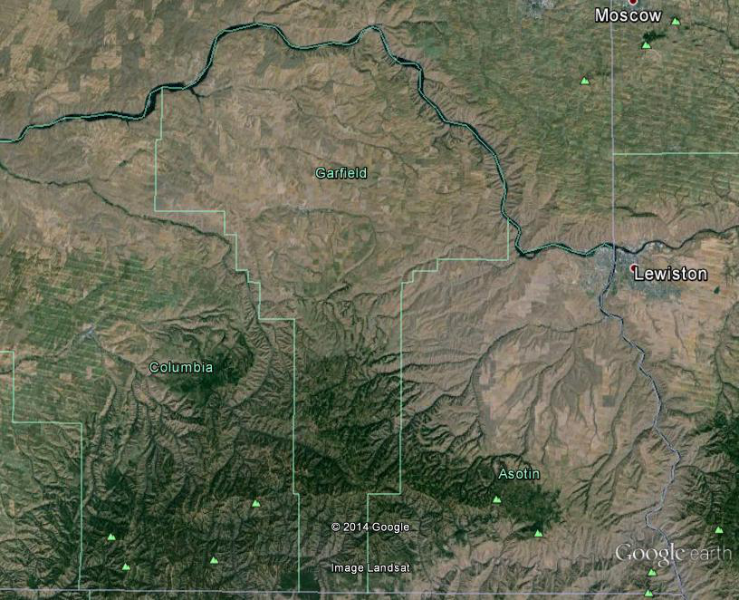

Priority Natural Resource Conservation Needs and Geographic Areas:

Priority Natural Resource Conservation Needed: Geographic Area

- Soil Health (nutrient management, erosion, etc.) Cropland and ranges acres
- Weed Management (noxious and invasive weeds) County Wide (Abandoned roads
Meadow Creek, Yellow Star areas)
- Water Quality (nutrients, temperature, other) Streams with Fish, livestock issues, and
roads by creeks
- Range Management (native vegetation, water availability range areas and small acre areas
- Riparian Health (stream bank conditions, vegetation, etc.) Streams with fish, livestock issues, and
roads by creeks
- Air Quality (field burning, prescribed burning, other) County Wide
- Wildlife County Wide
- Farmer Preservation (lens to look through at all above Resident input

Measures of Success & Measurable Goals:

Natural Resource Conservation Need | Measures of Success | Goal
Soil Health (nutrient management, erosion, etc. | - Acres of healthy soil based on indicators | By Dec. 2018 have a demonstrated increase in acres of healthy soil based indicators
Weed Management (Noxious and invasive weeds) | - Acres treated | By Dec. 2018 have a demonstrated increase of acres treated for noxious and invasive weeds
Water Quality (nutrients, temperature, other | - No regulatory actions  - Visual & Water quality measurement improvement | By Dec. 2018 have no regulatory actions and a demonstrated improvement of visual and water quality measurements
Range Management (water availability, improved range production) | - Acres of healthy range stands, free of noxious and evasive weeds, plant diversity  - Improved water availability | By Dec. 2018 have a demonstrated number of acres with healthy range stands and native plants  By Dec. 2018 have a demonstrated increase in water availability for livestock through new spring developments and other off site watering facilities.
Riparian Health (streambanks, other issues along stream corridor. | - Feet of healthy riparian area (native plant cover, stream shading, lower water temperature | By Dec. 2018 have a demonstrated increase in the feet of healthy riparian area including native plant cover, stream shading, and lower water temperature.
Air Quality (wildfire, prescribed burning, other | - # of complaints on air quality.  - Air quality measurements | By Dec. 2018 have a demonstrated decrease in number of complaints on air quality and a related improvement in air quality metrics.
District Operations | - Number of people contacted  - Number of people served  - Conservation plans developed  - Conservation practices implemented  - Projects completed  - Issues addressed  - % of funding to Cooperators for conservation work. | By Dec. 2018 have a demonstrated increase in:  Number of people contacted  Number of people served  Number of conservation plans developed and related conservation practices implemented.  Projects completed  Number and types of issues addressed  The % of funding to cooperators for conservation work

Milestones, Timeline, & Actions:
Natural Resource Conservation Need:
Soil Health (nutrient management, erosion, etc.)
Measurable Goal: By Dec. 2018 have a demonstrated increase in acres of healthy soil based on indicators

Milestones | Timeline | Actions
Soil tests completed on 25  % of soil in county | 2 to 3 years | - Increase soil testing done in county by 50%  - Increase in Direct Seeding acres  - Increase in tissue analysis being used  - Measured increase in organic matter and microbial health on 10,000 acres
25% decrease in soil delivery to streams in Garfield County | 2 to 3 years | - Long term historical chart of soil delivered by developing and analyzing available data  - Work with a few interested farmers on demonstrating how they are improving soil health  - Host demonstration day on soil health practices  - Use district rainfall simulator to show infiltration and runoff with different soil properties and protection
25% increase in variable rate technology used | 3 to 4 years | - Assist producers with yield monitors, variable rate technology use…cost share  - Hose producer networking sessions on technology use and related economics.

Natural Resource Conservation Need:
Weed Management
Measurable Goal: By 2018 have a demonstrated increase in acres treated for weed management

Milestones | Timeline | Actions
Address primary noxious weed issues in a strategic pattern within county | 5 years | - Assess with weed board where the problem areas are in order to concentrate treatment  - Work with landowners, operators, and government entities on weed treatments  - Setup standard options for cost share and treatment costs  - Biological controls used on 25% of affected acres
Reach 25 people with weed control issues |  | - Sponsor evening tours with weed board, extension, researchers.
Update conservation plans from interested farmers and ranchers and help to implement needed practices | 2 to 3 years | - Work with interested operators to update conservation plans and related conservation practices.

Natural Resource Conservation Need:
Water Quality (nutrients, temperature, other)
Measurable Goal: By 2018 have no regulatory actions, and a demonstrated improvement visual & water quality measurements

Milestones | Timeline | Actions
All landowners in county would have knowledge of water quality issues | 2 to 3 years | - Have public meetings with landowners to build a better understanding between agencies and landowners.
Identify areas of water quality concerns | 2 to 3 years. | - Evaluate the new areas in the county that need addressed
Provide information, tools, and options for producers to manage risk of water quality pollution including monitoring | 2 to 3 years. | - Figure out water quality measurements needed and establish or find an assessment tool for managing water quality pollution risk (visual, other)  - Work with specialists on water quality risk management tools  - Work with producers on options possible for managing water quality risk.  - Assist with locally led monitoring activities including photo monitoring

Natural Resource Conservation Need:
Range Management (water availability, other)
Measurable Goal:
By Dec. 2018 have a demonstrated number of acres with healthy range stands and plants
By Dec. 2018 have a demonstrated increase in water availability

Milestones | Timeline | Actions
Increasing carrying capacity, plant health and vigor, lower hay cost leading to demonstrated increase of beneficial ground cover in county | 2 to 3 years | - 20 water developments completed  - Fencing as management tool on 1,000 acres  - Range monitoring and production monitoring on 500 acres  - Use of new tools for range health and management  - Management of weed infestations on 1,000 acres.
Healthy livestock and wildlife |  | - Provide educational work session on grazing time management  - Time management implemented on 20 operations

Natural Resource Conservation Need:
Riparian Health (streambanks, other)
Measurable Goal:
By Dec. 2018 have a demonstrated number of acres with healthy vegetated non-eroding streambanks
By Dec. 2018 have a demonstrated increase of acres of healthy riparian area

Milestones | Timeline | Actions
Increase acres of healthy riparian area (native plant cover, stream shading, lower temperature | 4 to 5 years. | - Implement practices with natural and artificial means to project eroding streambanks.  - Implement 20 miles of CREP on eligible streams  - Work with operators to improve their riparian areas utilizing better livestock management practices.

Natural Resource Conservation Need:
Wildlife
Measurable Goal:
By Dec. 2018 have a demonstrated number of acres with healthy vegetated non-eroding streambanks
By Dec. 2018 have a demonstrated increase of acres of healthy riparian area

District Operations Priorities, Goals:

Technology & Conservation Education
  - By January 2013 have 50% increase in conservation technology use in the county; 90% of Garfield County citizens will be educated on district conservation programs with 100% availability; 75% increase in producers using GPS technology; 50% of the producers are using weed seeker technology by 2009
Actions (next 12 months):
  - Hold a class for producers on new conservation technology including demonstration areas
  - Put information in public places on conservation cost share and technology
  - Visit with local producers that are not practicing weed seeker and/or GPS technology regarding their interest.

Key Decision Makers:
- Conservation District Supervisors
- Local Work Group
- Local dealers with interest in building and maintaining the weed seeker equipment
- WRIA 35 group for implementation funding
- Producers that would demonstrate the technology
- Weed board
- Jerry Wilsey – volunteer assistance

Rangeland Management & Weed Control (rangeland & cropland)
- By January 2013 have cattleman involved in rangeland management (including weed management) leading to a successful treatment on 25% of the county rangeland acreage; and 80% of the producers will have a weed management program in place.
Actions (next 12 months):
- Find or produce a standardized planning template for range management and weed management
- Coordinate with the technical experts on the weed board and local district on information – education, infestations, producers with interest, and cost share activities
- Coordinate the activities with area agronomists – private industries

Key Decision Makers:
- All chemical representatives
- Courtney Smith
- Steve Ledgerwood, Beau Blachly and Ken Uto
- Representative to SE Weed Management Area

Air Quality
- By January 2013 reduce or eliminate agricultural burning by 2500 acres.
Actions (next 12 months):
- Burn 500 less acres next spring by going to the top few producers to attain this reduction
- Approach ag chemical dealers in town to promote reduce the tillage operations by one operation
- With the County Fire Commissioners & City Council to provide an education program on the need to eliminate burning in the city
- Explore Spokane CD low interest loan for composting equipment
- Work with Roger Dumbeck on the possible composting operation

Key Decision Makers:
- Three largest users of the burn program over last three years
- Chemical companies
- Fire commissioners & city council
- Spokane CD

Water Resources (Quality & Quantity)
- By January 2013 all cooperators will have an approved conservation plan to meet their objectives for implementation of conservation practices to improve water quality and conserve water quantity in order to receive cost share assistance.
Actions (next 12 months):
- Contact FSA and NRCS regarding farm planning for program activity
- Survey some cooperators to identify willingness to develop an updated conservation plan
- Check on funding for plan development and implementation including technical service provider funding

Key Decision Makers:
- WRIA 35
- BPA
- Ecology
- WSCC

District Operations & Funding (for all of the above)
- By January 2013 increase in funding from at least one additional source of funding annually; above adequate funding for programs above.
Actions (next 12 months):
- Sign the firewise agreement with Skagit CD
- Figure out what should be made available to demonstrate Weed Seeker technology – develop a business plan with revenue and expenses, rental agreement
- Make application to Spokane CD for low interest loan for Weed Seeker equipment if necessary
- Look at WRIA 35 implementation funding

Key Decision Makers:
- Spokane CD – Rich Baden
- Benton CD – Erin Fuhrer
- Brad Johnson and WRIA 35
- SE Cooperative Weed Management Area Group

Trends Impacting Conservation in the Pomeroy Conservation District
- Still have livestock related needs
- Increase needs on grazing lands and noxious weeds
- Profitability of farming – increased input costs & economy
- If world situation changes on commodities prices decrease we still will have associated high input costs
- Weather impacts
- Increase in weed infestations (tied to economics, profitability of farming and politics)
- Increase in technology
- Increase in water quantity and water quality issues
- Decrease in burning residue
- Increase in political pressures

Strategies to Address Trends
- Need to work on weed control issues – both rangeland and cropland – new technology introduced on methods of control
- More accessibility to cooperators on results of research and technology available – weed seeker, GPS systems, use of chemicals,
- Funding made available for the development of the programs above

Natural Resource Data:
Natural Resources Information & Status
- Forest Land
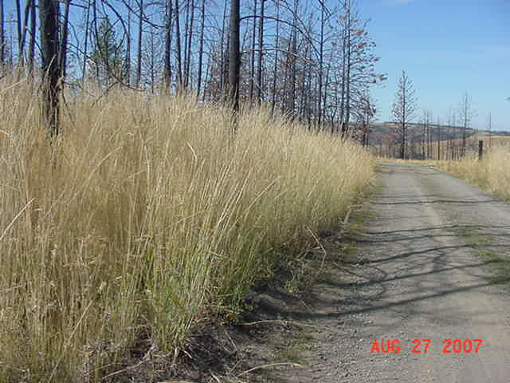
The school fire was basically the only forest land activity covered by Conservation District
programs. The USFS works on their land within the Umatilla National Forest and the DNR works with landowners on private and state property. The grass seeding project completed by the district with funding from the Commission was a tremendous success. It grew to such a degree as the picture illustrates that it could be a fire hazard in it’s self.
- Cropland
Of the 221,544 acres of farmable cropland in Garfield County, roughly 150,000 acres has been treated with some degree of cost share from the Conservation District or a federal farm program (EQIP) that followed practices implemented from district programs. Additional federal funding is being utilized in programs such as CRP, CREP, and EQIP to protect another third of the cropland. The remaining third still needs funding of some kind to bring it to the level of the remaining county.
- Rangeland
The 131,000 acres of pasture and rangeland in Garfield County is in dir need of improved management. At this point in time the district has been unable to obtain the necessary funding from any source to effectively address the yellow star and skeleton weed problems that are currently reducing the quality of our rangeland.

Staffing Needs
- We currently have two full time employees with two part time. This staffing is sufficient to implement the plan as stated above.

Annual Budget Needs

FY2009 Annual Budget

Pomeroy Conservation District

 | Income
Lead Entity | $6,000
DOE Grant | $100,000
Good Governance | $10,700
BPA | $45,000
Livestock Influenced Water Quality | $22,000
PIP Loan | $25,000
CREP grant | $70,000
Implementation grant | $35,000
Burn Permits | $17,000
Maps | $50.00
Raingauges | $15.00
Tree Sales | $10,000
Soil testing | $4,500
Interest earned | $275
Grader Rental | $5,000
Firewise | $15,000
Miscellaneous income | $1,000
Total Income | $366,540
 | Expenses
Internet Service | $275
Dist. Mgr. Wages | $47,500
Dist. Tech Wages | $30,250
Soil Lab Wages | $2,000
CREP Status Reviewer | $3,500
Employee Benefits | $30,000
Lab Supplies | $1,500
Copier Expenses | $2,800
Weather Station | $1,200
Travel Per Diem | $500
Election Expenses | $125
Legal Notices | $50
Bond, Liability, vehicle insurance | $3,000
Office Supplies | $600
Dues | $3,875
Lab Rent | $780
Cellphone | $350
Computer expense | $1,000
Information Education | $1,500
Postage | $425
Storage at Port | $660
Trees, maps, etc. | $9,500
Vehicle license | $110
Grader fuel, maint. | $1,200
Sales tax, B&O | $300
PIP loans | $25,000
Cost share (all programs) | $198,540
Total Expenses | $366,540

Key Decision Makers
- Supervisors of the Pomeroy Conservation District

Priority Actions – 12 Months
Action Plan: 2009

Program Area: Technology & Conservation Education
Measurable Goal: By January 2013 have 50% increase in conservation technology use in the county; 90% of Garfield County citizens will be educated on district conservation programs with 100% availability; 75% increase in producers using GPS technology; 50% of the producers are using weed seeker technology.

Strategies:
Funding Source(s):
Activities for FY2009 | Target Dates | Person  Responsible | Time(Days) Required | Estimated Funding
- Hold a class for producers on new conservation technology including demonstration areas | April | Duane Bartels | 1 day | $500
- Put information in public places on conservation cost share and technology | On-going | Marie Gormsen | 1 days | $200
- Visit with local producers that are not practicing weed seeker and/or GPS technology regarding their interest. | On-going | Duane Bartels | 6 days | $1,800
 |  |  |  | $2,500

Program Area: Rangeland Management & Weed Control (rangeland & cropland)
Measurable Goal: By January 2013 have cattlemen involved in rangeland management (including weed management) leading to a successful treatment on 25% of the county rangeland acreage; and 80% of the producers will have a weed management program in place

Strategies:
Funding Source(s):
Activities for FY2009 | Target Dates | Person  Responsible | Time(Days) Required | Estimated Funding
- Find or produce a standardized planning template for range management and weed management | On going | Duane Bartels | 2 days | $600
- Coordinate with the technical experts on the weed board and local district on information – education, infestations, producers with interest, and cost share activities | On going | Duane Bartels | 20 days | $6,000
- Coordinate the activities with area agronomists – private industries | On going | Duane Bartels | 5 days | $1,500

Program Area: Air Quality
Goal(s): By January 2013 reduce or eliminate agricultural burning by 2500 acres.
Strategies:
Funding Source(s):
Activities for FY2009 | Target Dates | Person  Responsible | Time(Days) Required | Estimated Funding
- Burn 500 less acres next spring by going to the top few producers to attain this reduction | Spring | Duane Bartels | 1 day | $300
- Approach ag chemical dealers in town to promote reduce the tillage operations by one operation | On going | Duane Bartels | 5 days | $1,500
- With the County Fire Commissioners & City Council to provide an education program on the need to eliminate burning in the city | On going | Duane Bartels | 2 days | $600
- Explore Spokane CD low interest loan for composting equipment | Spring | Duane Bartels | 1 day | $300
- Work with Roger Dumbeck on the possible composting operation | Spring | Duane Bartels | 1 day | $300

Program Area: Water Resources (Quality & Quantity)
Goal: By January 2013 all cooperators will have an approved conservation plan to meet their objectives for implementation of conservation practices to improve water quality and conserve water quantity in order to receive cost share assistance.
Strategies:
Funding Source(s):
Activities for FY2009 | Target Dates | Person  Responsible | Time(Days) Required | Estimated Funding
- Contact FSA and NRCS regarding farm planning for program activity | On going | Duane Bartels | 2 days | $600
- Survey some cooperators to identify willingness to develop an updated conservation plan | On going | Duane Bartels | 2 days | $600
- Check on funding for plan development and implementation including technical service provider funding | On going | Duane Bartels | 2 days | $600

Program Area: District Operations & Funding (for all of the above)
Goal(s): By January 2013 increase in funding from at least one additional source of funding annually; above adequate funding for programs above.
Strategies:
Funding Source(s):
Activities for FY2009 | Target Dates | Person  Responsible | Time(Days) Required | Estimated Funding
- Sign the firewise agreement with Skagit CD and begin implementing program. | Feb. | Duane Bartels | 1 day | $300
- Figure out what should be made available to demonstrate Weed Seeker technology – develop a business plan with revenue and expenses, rental agreement | Mar. | Duane Bartels | 2 days | $600
- Make application to Spokane CD for low interest loan for Weed Seeker equipment if needed. | If needed | Duane Bartels | 1 day | $300
- Look at WRIA 35 implementation funding | If needed | Duane Bartels | 3 days | $900
- Administer all cost share programs not covered above. | On going | Duane & Marie | 70 days | $17,500

Washington Conservation Districts assisting land
managers with their conservation choices

